 | THE UNIVERSITY COLLEGE  OF THE CARIBOO  Computing Science

COMP 113 & 152 - Computer Programming I (3,1,1)
Fall 2004
Lab Exercise 3

Due: Beginning of lab session in the week of October 4 to 8.

Self-Review Questions: (answers are provided at the end of the chapter)
- page 78, questions: #18, #19
- page 78, questions: #22, #23
- page 87, question: #26
- page 88, question: #32 (**interesting)

Preparation:
Read Section 2.2 in the text (pages 68-78). This section covers the String class.
As an example of applying the String class methods, use the program in Display 2.8 (page 76).

Problems:
Create program solutions for both of the following problems. Only one will be marked.

- Input a sentence that has the words energetic and lazy in it. Your program will exchange the locations of the 2 words as it displays the sentence.
Your program must work for any input sentence that has these two words (you can assume that neither words starts the sentence). Further, the input sentence has only one occurrence of each word.
Example 1 (user input is in bold),
Please input the sentence:
The energetic dog jumped over the lazy cat.

The new sentence is:
The lazy dog jumped over the energetic cat.
Example 2 (user input is in bold),
Please input the sentence:
a lazy energetic a

The new sentence is:
a energetic lazy a

- Using the Integer.parseInt() and Double.parseDouble() methods to translate a String to an value, GUI input almost demands the input of one value per input dialog window. By using the concepts from the problem above, from a single large input String, individual Strings can be extracted and translated to numeric values.

Write a program that asks the user for exactly 3 integers from a single GUI input dialog, separating the numbers with a comma (,). Display sum of the numbers in an output dialog.
(hint: Use the input String from the input dialog in the output dialog.)

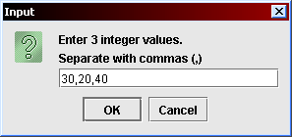
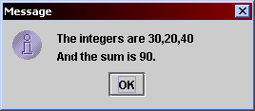
Example:

Results:
Submit a print of both programs’ source code and samples of each one’s output; provide output of at least two executions of each program (use the screen capture method from the first lab).

