 | THE UNIVERSITY COLLEGE  OF THE CARIBOO  Computing Science

COMP 113 & 152 - Computer Programming I (3,1,1)
Fall 2004
Lab Exercise 5

Due: Beginning of lab session in the week of October 18 to 22, 2004.

Self-Review Questions: (answers are provided at the end of the chapter)
- page 140, question: #22
- page 147, question: #23
- page 148, question: #26 – note the ; at the end of the for-loop)
- page 148, question: #28 – write the code segment using the fewest variables and statements possible!!

- page 151, questions: #29, #30 – what is the difference between statements break; and System.exit(0);
- page 162, question: #37 – very interesting!!

- page 170, questions: #40, #41 – Boolean logic

Problems:
Create program solutions for the following problems.
- From the previous lab, review your solution to Programming Project 1 on page 177.
But instead of using an if-else if decision structure, change the program to use the switch statement.
Hint: The char type is an integer, and can be used directly by switch. When matching with case, the single character can be used, such as:
switch (charValue)
{
case 'x':

- From the previous lab, review your solution to Programming Project 3 (page 178).
While keeping the basic structure of your original program, modify it in the following ways:
Version A:
  - rather than let the user provide the number of expected values, let the input continue until a sentinel value of zero (0) is input by the user
Version B:
  - if your original solution used a while-loop, modify it to use a for-loop to count up from 1 to the number of values to be input; if your original solution used a for-loop, modify it to use a while-loop.
Version C:
  - rather than let the user provide the number of expected values, ask the user if there is more data and continue until the user says “no”. Use a do–while loop.

- Do Programming Project 4 on page 178, but write it using a GUI.
Suggestions:
  - as the exam scores are entered, the program needs to keep track of: the total number of marks entered, a counter for each grade range (so 5 counters) the loop is sentinel controlled (the sentinel is a negative score, such as -1), and may encounter the sentinel value as the first score entered; therefore, a while loop is best applicable
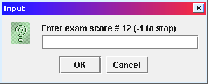
  - each score will be entered in is own input dialog window, but the window must display which score is being asked for:

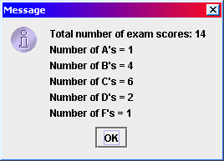
  - the output must be in a single output dialog window; therefore the program must store the result messages in an output string,

  - as an extra challenge, your program will show the average of the group as a numeric value in the output string, for which you should also keep track of the sum of the marks

Results:
For problems #1, #2, and #3, submit a print of the program's source code.
For problem #3, submit a print of the screen captures.

